**Enterprise Application Programming III**

**Project Status and Design Report**

|  |  |
| --- | --- |
| **Topic:** | *Initial Scrum Planning Milestone 1* |
| **Date:** | *1-21-2018* |
| **Revision:** | *1.0* |
| **Team:** | 1. *Jordan Riley* |
| 1. *Antonio Jabrail* |
|  |
|  |

**Planning Documentation**

**Agile Scrum Product Backlog:**

<https://github.com/jriley15/CST-247/blob/af87323530f1247459e121993088a77b9e0458eb/Milestone%201/Planning%20and%20design/Sprint%20Product%20Log%20Template.xls>

**Agile Scrum Sprint Backlog:**

<https://github.com/jriley15/CST-247/blob/af87323530f1247459e121993088a77b9e0458eb/Milestone%201/Planning%20and%20design/Sprint%20Product%20Log%20Template.xls>

**Agile Scrum Burn Down Chart:**

<https://github.com/jriley15/CST-247/blob/af87323530f1247459e121993088a77b9e0458eb/Milestone%201/Planning%20and%20design/Sprint%20Burn%20Down%20Template%20(2%20week).xlsx>

**Agile Retrospective Results:**

|  |
| --- |
| **What Went Well** |
| Planning |
| Communication between team |
| Taking advantage of team members individual skills |

|  |  |  |
| --- | --- | --- |
| **What Did Not Go Well** | **Action Plan** | **Due Date** |
| Nothing | N/A |  |
|  |  |  |
|  |  |  |

**Design Documentation**

**ER Diagram:**

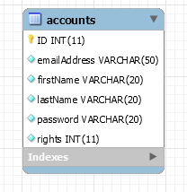

**Wireframe Diagrams:**

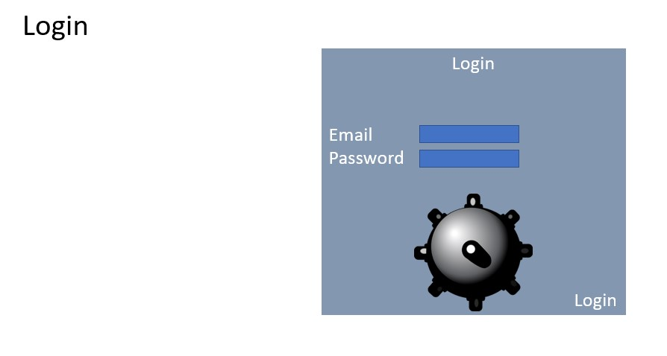

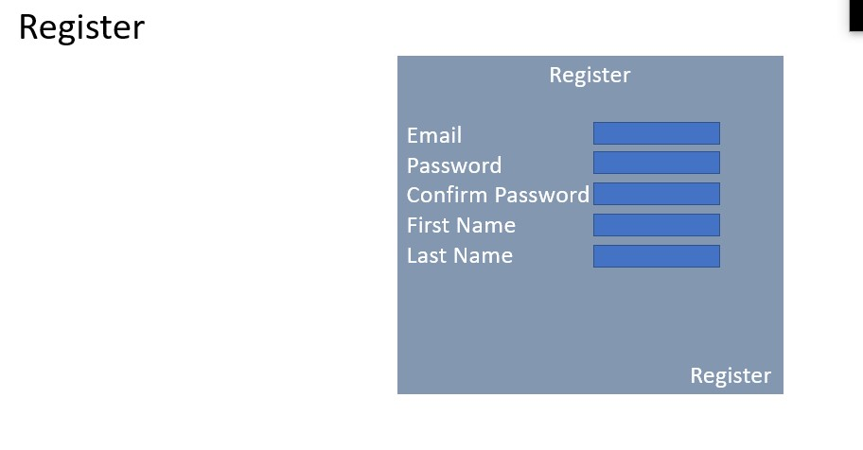

**Risks Identified:**

**Class Diagrams:**

*You should insert any class diagrams here. Your class diagrams should be drawn correctly with the 3 appropriate class compartments, + and – minus to indicate accessibility, and also the data types for the state/properties as well as method arguments and return types. If you have no supporting documentation please explain the rational why you are able to leave this section as N/A.*